INVOICE

Issued by: “ALL IN LOG” MMC Date and place
TIN: 1506805111
___________________________________________________________
Account: AZ60AIIB401500H8404261551218
TIN: 1506805111
Bank: KapitalBank ASC, Bravo 3 branch
SWIFT: AIIBAZ2XXXX
Bank TIN: 9900003611
Code: 201296
Correspondent Bank: Bank of New York Mellon; SWIFT: IRVTUS3N; Correspondent account: 8901723762
________________________________________________________________________________
Buyer (Payer):
TIN:

No. | Description of work | Quantity  (units) | Total amount  (USD)
1
Total
VAT 18%
Grand total
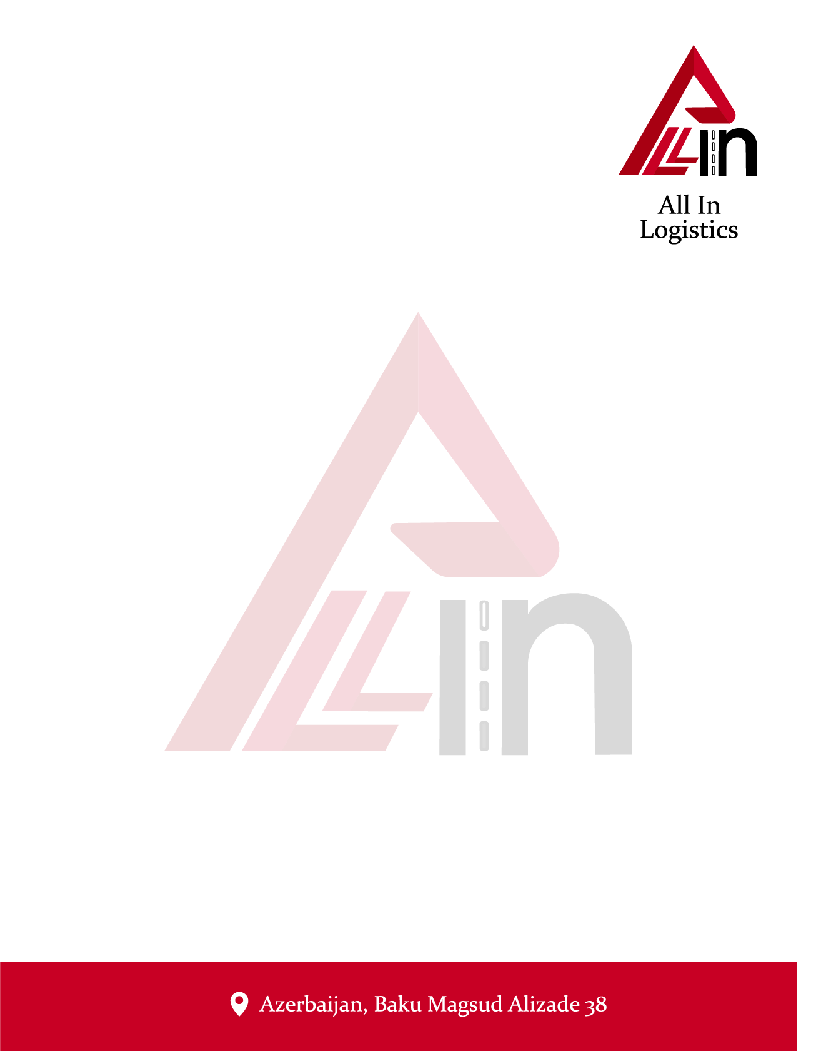

Director: Ələkbərov Vüsal

